**Ideation Phase**

**Empathize & Discover**

|  |  |
| --- | --- |
| Date | 10 JANUARY 2025 |
| Team ID | SWTID1743254297 |
| Project Name | TUNETRAIL- YOUR PATHWAY TO PERFECT PLAYLIST |
| Maximum Marks | 4 Marks |

**Empathy Map Canvas**

To better understand the needs and experiences of our users, we created an **Empathy Map Canvas** based on surveys and interviews with potential users. Here's what we discovered:

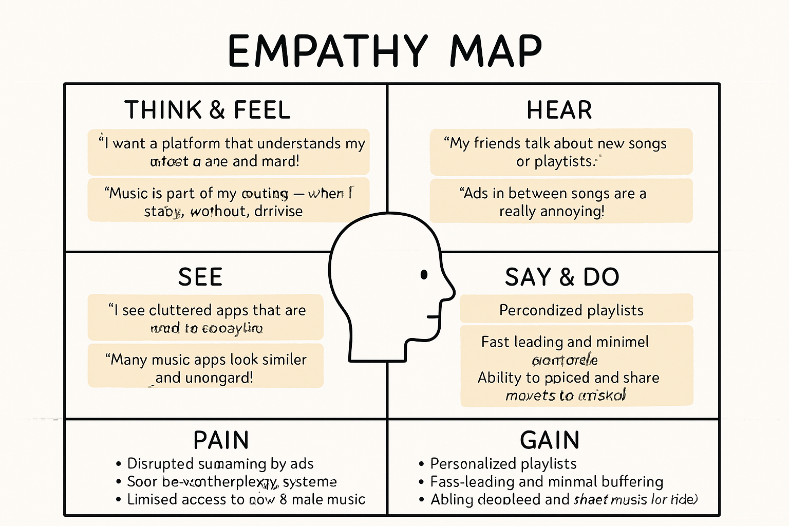

|  |  |  |
| --- | --- | --- |
|  |  |  |
| **Category** |  | **User Insights** |
| **Think & Feel** |  | “I want a platform that understands my music taste and mood.” “Music is part of my routine—when I study, workout, or relax.” |
| **Hear** |  | “My friends talk about new songs or playlists.” “Ads in between songs are really annoying.” |
| **See** |  | “I see cluttered apps that are hard to navigate.” “Many music apps look similar and unoriginal.” |
| **Say & Do** |  | “I usually search for specific songs or artists.” “I share music via links or social media.” |
| **Pain** |  | - Disrupted streaming by ads |

* Poor recommendation systems
* Limited access to new or indie music | | **Gain** | - Personalized playlists
* Fast loading and minimal buffering
* Ability to upload and share music (for artists) |

The empathy map helped us gain valuable insights into both listener and artist needs, influencing our feature planning and user experience design.